Page-Replacement-and-Scheduling
Team members: Cameron Bailey, Bryant Peden

The overview of the problem was two major challenges, memory management problems and CPU scheduling problems. Our objective was to test and run the LRU, FIFO, and Round Robin algorithms with efficiency to get the best outputs to solve these problems. The main questions were, “Which one is the best all around?” and “When do you know which one you should choose?” The experiment went good as planned, the coding went as expected and from the way that we had it set up, we were able to run one individual python code that would give us results to all the algorithms to save time and show answers all together. Here, you can also change the inputs of both the page replacement algorithms and the scheduling algorithms. This helped to bring variety to try out other answers and seeing what it can get you. The results came through with clean answers and no errors. For page replacements, it showed how many page faults occurred, and for the Round Robin, it showed the waiting time, the turnaround time and the averages for both. The results came back easily; I will have the picture of the answers that can also be found in the GitHub. Through empirical analysis of FIFO, LRU, and Round Robin, we observed that LRU generally results in fewer page faults than FIFO because it considers recent usage, while FIFO ignores usage patterns and can perform worse. Round Robin provides fair CPU scheduling, but its efficiency depends on the chosen time quantum, affecting overhead and responsiveness. The experiment was limited by a small set of test cases and fixed parameters, which may not reflect real-world conditions. If repeated, the study could include more diverse inputs and additional performance metrics. These results also suggest exploring other algorithms and optimization strategies in future work.
There were a couple of roadblocks throughout the entire time. The biggest one was trying to find out how exactly we could implement the two types of algorithms and make a comparison and contrast with each because they are so different. A difficulty that took a while to complete was the coding, I wanted to make the code clean and grouped up together to where all of the coding could be tested in one spot and also make it to where the input can be altered instead of asking the user, it would be unnecessary.
Sources:
https://www.geeksforgeeks.org/operating-systems/page-replacement-algorithms-in-operating-systems/
https://www.geeksforgeeks.org/operating-systems/round-robin-scheduling-in-operating-system/
Some GenAI was used to help create questions and ideas to help create a start.
Results:
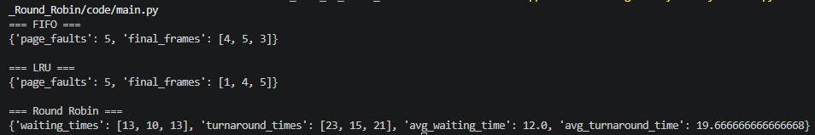
Work done:
Work done | Cameron Bailey | Bryant Peden
brainstorming | yes | yes
coding | yes | no
experiment | yes | yes
presentation | yes | yes
design | yes | no
communication | yes | yes
submission | yes | no
Report writing | yes | no

